

Web Technologies (CSE4004)

**Mini Project**

**Easy Quiz**

Created By: Aarsh Patel (20BCN7014)

Under the Guidance of Dr. Mudigonda Krishna Siva Prasad

**Project Description:**

So Easy Quiz is an Online Platform where the quiz can be conducted in a much easy way and no need to worry about the assigning the question and evaluation of quiz, everything is done in well efficient ways, as the user who want to assign the question just have to enter the number of the questions and it is option and mention the correct answer. As after the completion of the quiz there will be automatically calculation of the marks of the user who is taking test on these platforms so to do these process and check which is right and wrong answer, so we need to correct answer of the question. So, after evaluation of the answer there is display of the data about the performance of the user that how many marks obtained, correct answer, wrong answer and final display of the marks that user has obtained int the quiz and all the records of the users are being store in database so that record can be used to compare the present and past record of the user so if the user need improvement in study so they can look at statical data and prepare well for the next quiz

So online quizzes are set up to actually test knowledge or identify a person's attributes. So, this platform is being used by various organization such as in school, college, companies etc. As these Quizzes help students identify what they know and what they don't know. The students then have a better idea of how well they are grasping the material, hopefully motivating them to study more and helping them allocate their study time effectively by focusing on the information that still needs more practice

**Source Code:**

Login page::

<?php

    require('database.php');

**session_start**();

    if(**isset**($_SESSION["email"]))

    {

**session_destroy**();

    }

    $ref=@$_GET['q'];

    if(**isset**($_POST['submit']))

    {

        $email = $_POST['email'];

        $pass = $_POST['password'];

        $email = **mysqli_real_escape_string**($con,$email);

        $pass = **mysqli_real_escape_string**($con,$pass);

        $str = "SELECT * FROM user WHERE email='$email' and password='$pass'";

        $result = **mysqli_query**($con,$str);

        if((**mysqli_num_rows**($result))!=1)

        {

**echo** "<center><h3><script>alert('Sorry.. Wrong Username (or) Password');</script></h3></center>";

**header**("refresh:0;url=login.php");

        }

        else

        {

            $_SESSION['logged']=$email;

            $row=**mysqli_fetch_array**($result);

            $_SESSION['name']=$row[1];

            $_SESSION['id']=$row[0];

            $_SESSION['email']=$row[2];

            $_SESSION['password']=$row[3];

**header**('location: welcome.php?q=1');

        }

    }

?>

<!DOCTYPE *html*>

<html>

    <head>

        <meta *charset*="UTF-8">

        <meta *name*="viewport" *content*="width=device-width, initial-scale=1.0">

        <meta *http-equiv*="X-UA-Compatible" *content*="ie=edge">

        <title>Easy Quiz</title>

        <link *rel*="stylesheet" *href*="scripts/bootstrap/bootstrap.min.css">

        <link *rel*="stylesheet" *href*="scripts/ionicons/css/ionicons.min.css">

        <link *rel*="stylesheet" *href*="css/form.css">

        <style *type*="text/css">

            body{

                  width: 100%;

                  background: **url**(image/book.jpg) ;

                  background-position: center center;

                  background-repeat: no-repeat;

                  background-attachment: fixed;

                  background-size: cover;

                }

          </style>

    </head>

    <body>

        <section *class*="login first grey">

            <div *class*="container">

                <div *class*="box-wrapper">

                    <div *class*="box box-border">

                        <div *class*="box-body">

                        <center> <h5 *style*="font-family: Noto Sans;">Login to </h5><h4 *style*="font-family: Noto Sans;">Online Quiz System</h4></center><br>

                            <form *method*="post" *action*="login.php" *enctype*="multipart/form-data">

                                <div *class*="form-group">

                                    <label>Enter Your Email Id:</label>

                                    <input *type*="email" *name*="email" *class*="form-control">

                                </div>

                                <div *class*="form-group">

                                    <label *class*="fw">Enter Your Password:

                                        <a *href*="javascript:void(0)" *class*="pull-right">Forgot Password?</a>

                                    </label>

                                    <input *type*="password" *name*="password" *class*="form-control">

                                </div>

                                <div *class*="form-group text-right">

                                    <button *class*="btn btn-primary btn-block" *name*="submit">Login</button>

                                </div>

                                <div *class*="form-group text-center">

                                    <span *class*="text-muted">Don't have an account?</span> <a *href*="register.php">Register</a> Here..

                                </div>

                            </form>

                        </div>

                    </div>

                </div>

            </div>

        </section>  </body></html>

Index Page:

<!DOCTYPE *html*>

<html *lang*="en">

    <head>

        <meta *charset*="UTF-8">

        <meta *name*="viewport" *content*="width=device-width, initial-scale=1.0">

        <meta *http-equiv*="X-UA-Compatible" *content*="ie=edge">

        <title> Easy Quiz</title>

        <link *rel*="stylesheet" *type*="text/css" *href*="css/index.css" />

        <link *rel*="shortcut icon" *type*="image/png" *href*="image/logo.png" />

        <style *type*="text/css">

            body {

                width: 100%;

                background: **url**(image/book.jpg);

                background-position: center center;

                background-repeat: no-repeat;

                background-attachment: fixed;

                background-size: cover;

                color:black;

            }

            .btn{

                color:black;

                border:5px solid;

            }

            h1{

                color:black;

            }

        </style>

    </head>

    <body>

        <center>

            <div *class*="intro">

                <h1> online quiz system </h1>

                <a *href*="login.php" *class*="btn"> login </a> &emsp;

                <a *href*="register.php" *class*="btn"> register </a>

                <h2> Good &nbsp;Luck. </h2>

            </div>

        </center>

    </body>

</html>

Register

<?php

    include("database.php");

**session_start**();

    if(**isset**($_POST['submit']))

    {

        $name = $_POST['name'];

        $name = **stripslashes**($name);

        $name = **addslashes**($name);

        $email = $_POST['email'];

        $email = **stripslashes**($email);

        $email = **addslashes**($email);

        $password = $_POST['password'];

        $password = **stripslashes**($password);

        $password = **addslashes**($password);

        $college = $_POST['college'];

        $college = **stripslashes**($college);

        $college = **addslashes**($college);

        $str="SELECT email from user WHERE email='$email'";

        $result=**mysqli_query**($con,$str);

        if((**mysqli_num_rows**($result))>0)

        {

**echo** "<center><h3><script>alert('Sorry.. This email is already registered !!');</script></h3></center>";

**header**("refresh:0;url=login.php");

        }

        else

        {

            $str="insert into user set name='$name',email='$email',password='$password',college='$college'";

            if((**mysqli_query**($con,$str)))

**echo** "<center><h3><script>alert('Congrats.. You have successfully registered !!');</script></h3></center>";

**header**('location: welcome.php?q=1');

        }

    }

?>

<!DOCTYPE *html*>

<html>

    <head>

        <meta *charset*="UTF-8">

        <meta *name*="viewport" *content*="width=device-width, initial-scale=1.0">

        <meta *http-equiv*="X-UA-Compatible" *content*="ie=edge">

        <title>Easy Quiz</title>

        <link *rel*="stylesheet" *href*="scripts/bootstrap/bootstrap.min.css">

        <link *rel*="stylesheet" *href*="scripts/ionicons/css/ionicons.min.css">

        <link *rel*="stylesheet" *href*="css/form.css">

        <style *type*="text/css">

            body{

                  width: 100%;

                  background: **url**(image/book.png) ;

                  background-position: center center;

                  background-repeat: no-repeat;

                  background-attachment: fixed;

                  background-size: cover;

                }

          </style>

    </head>

    <body>

        <section *class*="login first grey">

            <div *class*="container">

                <div *class*="box-wrapper">

                    <div *class*="box box-border">

                        <div *class*="box-body">

                            <center> <h5 *style*="font-family: Noto Sans;">Register to </h5><h4 *style*="font-family: Noto Sans;">Online Quiz System</h4></center><br>

                            <form *method*="post" *action*="register.php" *enctype*="multipart/form-data">

                                <div *class*="form-group">

                                    <label>Enter Your Username:</label>

                                    <input *type*="text" *name*="name" *class*="form-control" *required* />

                                </div>

                                <div *class*="form-group">

                                    <label>Enter Your Email Id:</label>

                                    <input *type*="email" *name*="email" *class*="form-control" *required* />

                                </div>

                                <div *class*="form-group">

                                    <label>Enter Your Password:</label>

                                    <input *type*="password" *name*="password" *class*="form-control" *required* />

                                </div>

                                <div *class*="form-group">

                                    <label>Enter Your College Name:</label>

                                    <input *type*="text" *name*="college" *class*="form-control" *required* />

                                </div>

                                <div *class*="form-group text-right">

                                    <button *class*="btn btn-primary btn-block" *name*="submit">Register</button>

                                </div>

                                <div *class*="form-group text-center">

                                    <span *class*="text-muted">Already have an account! </span> <a *href*="login.php">Login </a> Here..

                                </div>

                            </form>

                        </div>

                    </div>

                </div>

            </div>

        </section>

            </body>

</html>

Dashboard:

<?php

    include_once 'database.php';

**session_start**();

    if(!(**isset**($_SESSION['email'])))

    {

**header**("location:login.php");

    }

    else

    {

        $name = $_SESSION['name'];

        $email = $_SESSION['email'];

        include_once 'database.php';

    }

?>

<!DOCTYPE *html*>

<html>

<head>

    <meta *charset*="UTF-8">

    <meta *name*="viewport" *content*="width=device-width, initial-scale=1.0">

    <meta *http-equiv*="X-UA-Compatible" *content*="ie=edge">

    <title>Easy Quiz</title>

    <link  *rel*="stylesheet" *href*="css/bootstrap.min.css"/>

    <link  *rel*="stylesheet" *href*="css/bootstrap-theme.min.css"/>

    <link *rel*="stylesheet" *href*="css/welcome.css">

    <link  *rel*="stylesheet" *href*="css/font.css">

</head>

<body>

    <nav *class*="navbar navbar-default title1">

        <div *class*="container-fluid">

            <div *class*="navbar-header">

                <button *type*="button" *class*="navbar-toggle collapsed" *data-toggle*="collapse" *data-target*="#bs-example-navbar-collapse-1" *aria-expanded*="false">

                    <span *class*="sr-only">Toggle navigation</span>

                    <span *class*="icon-bar"></span>

                    <span *class*="icon-bar"></span>

                    <span *class*="icon-bar"></span>

                    <span *class*="icon-bar"></span>

                </button>

                <a *class*="navbar-brand" *href*="Javascript:void(0)"><b>Online Quiz System</b></a>

            </div>

            <div *class*="collapse navbar-collapse" *id*="bs-example-navbar-collapse-1">

                <ul *class*="nav navbar-nav navbar-left">

                    <li <?php if(@$_GET['q']==0) **echo**'class="active"'; ?>><a *href*="dashboard.php?q=0">Home<span *class*="sr-only">(current)</span></a></li>

                    <li <?php if(@$_GET['q']==1) **echo**'class="active"'; ?>><a *href*="dashboard.php?q=1">User</a></li>

                    <li <?php if(@$_GET['q']==2) **echo**'class="active"'; ?>><a *href*="dashboard.php?q=2">Ranking</a></li>

                    <li *class*="dropdown <?php if(@$_GET['q']==4 || @$_GET['q']==5) **echo**'active"'; ?>">

                       </ul>

                <ul *class*="nav navbar-nav navbar-right">

                    <li <?php **echo**''; ?> > <a *href*="logout1.php?q=dashboard.php"><span *class*="glyphicon glyphicon-log-out" *aria-hidden*="true"></span>&nbsp;Log out</a></li>

                </ul>

            </div>

        </div>

    </nav>

    <div *class*="container">

        <div *class*="row">

            <div *class*="col-md-12">

                <?php

                if(@$_GET['q']== 2)

                {

                    $q=**mysqli_query**($con,"SELECT * FROM **rank**  ORDER BY score DESC " )or die('Error223');

**echo**  '<div class="panel title"><div class="table-responsive">

                    <table class="table table-striped title1" >

                    <tr style="color:red"><td><center><b>Rank</b></center></td><td><center><b>Name</b></center></td><td><center><b>Score</b></center></td></tr>';

                    $c=0;

                    while($row=**mysqli_fetch_array**($q) )

                    {

                        $e=$row['email'];

                        $s=$row['score'];

                        $q12=**mysqli_query**($con,"SELECT * FROM user WHERE email='$e' " )or die('Error231');

                        while($row=**mysqli_fetch_array**($q12) )

                        {

                            $name=$row['name'];

                            $college=$row['college'];

                        }

                        $c++;

**echo** '<tr><td style="color:#99cc32"><center><b>'.$c.'</b></center></td><td><center>'.$e.'</center></td><td><center>'.$s.'</center></td>';

                    }

**echo** '</table></div></div>';

                }

                ?>

                <?php

                    if(@$_GET['q']==1)

                    {

                        $result = **mysqli_query**($con,"SELECT * FROM user") or die('Error');

**echo**  '<div class="panel"><div class="table-responsive"><table class="table table-striped title1">

                        <tr><td><center><b>S.N.</b></center></td><td><center><b>Name</b></center></td><td><center><b>College</b></center></td><td><center><b>Email</b></center></td><td><center><b>Action</b></center></td></tr>';

                        $c=1;

                        while($row = **mysqli_fetch_array**($result))

                        {

                            $name = $row['name'];

                            $email = $row['email'];

                            $college = $row['college'];

**echo** '<tr><td><center>'.$c++.'</center></td><td><center>'.$name.'</center></td><td><center>'.$college.'</center></td><td><center>'.$email.'</center></td><td><center><a title="Delete User" href="update.php?demail='.$email.'"><b><span class="glyphicon glyphicon-trash" aria-hidden="true"></span></b></a></center></td></tr>';

                        }

                        $c=0;

**echo** '</table></div></div>';

                    }

                ?>

            </div>

        </div>

    </div>

</body>

</html>

**Output:**

So, this is a First Page as you open it Easy Quiz, so here you can see the two buttons are there is that is login and register so let look it



In Register button where the new user can register first and then they can access these easy quiz site and attend the quiz



Going on login button where you can login in the Easy Quiz Site and attend the quiz if you haven’t Register than it would show and error and need to register to access these site



New user has to enter the data which is required and get register to this Easy Quiz

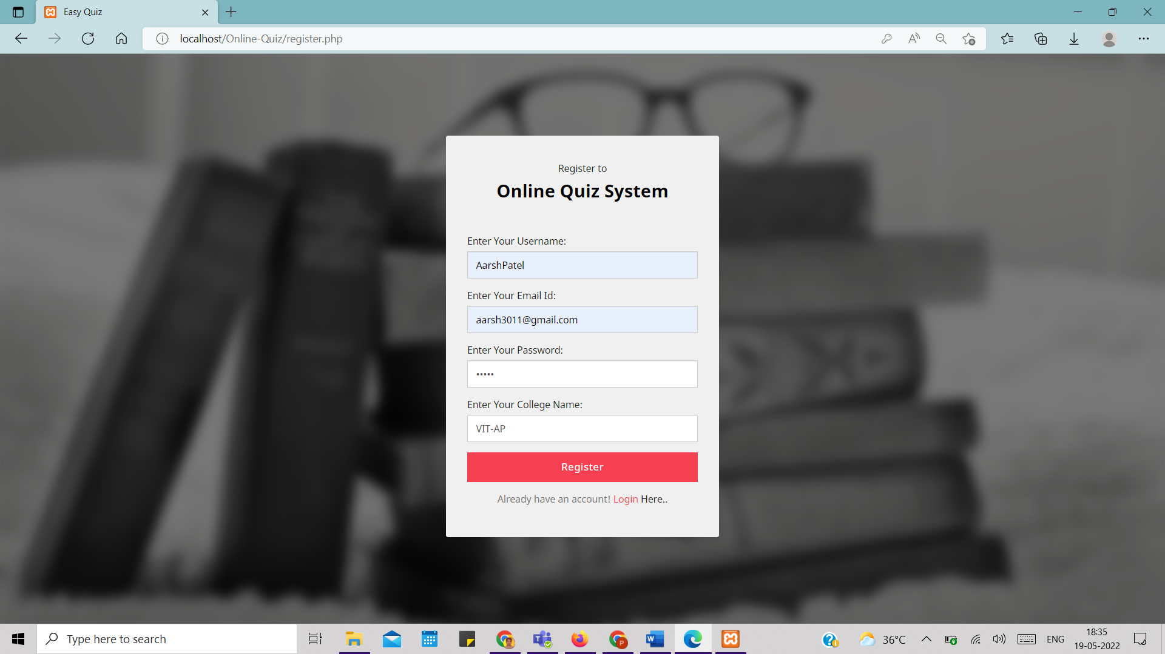

And in this register, there is also validation that user can’t add sane email for different names

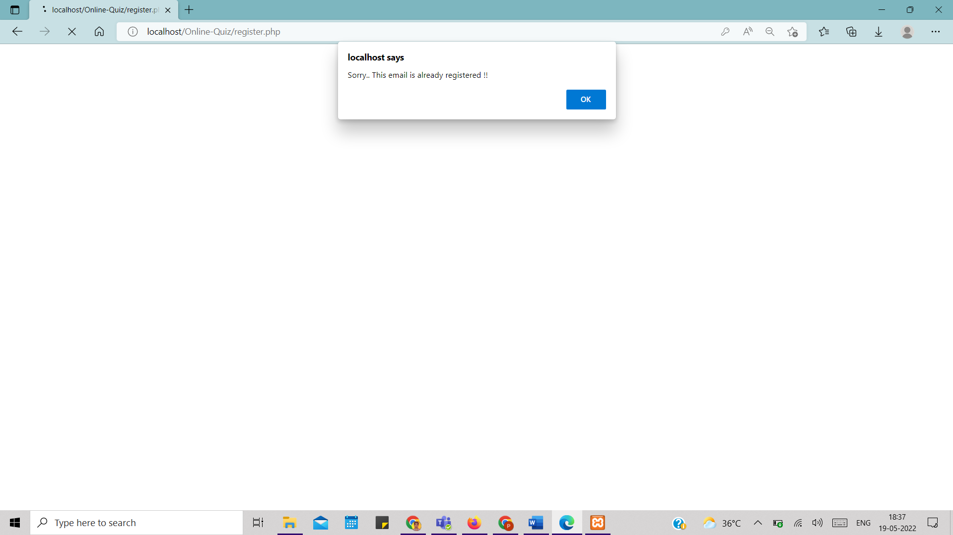

Once you are register for these Easy Quiz site you need to login in these pages by entering the email and password so here in this validation is there with the database and system check the enter data in login page is same as data store in database which we have created database while registering the users

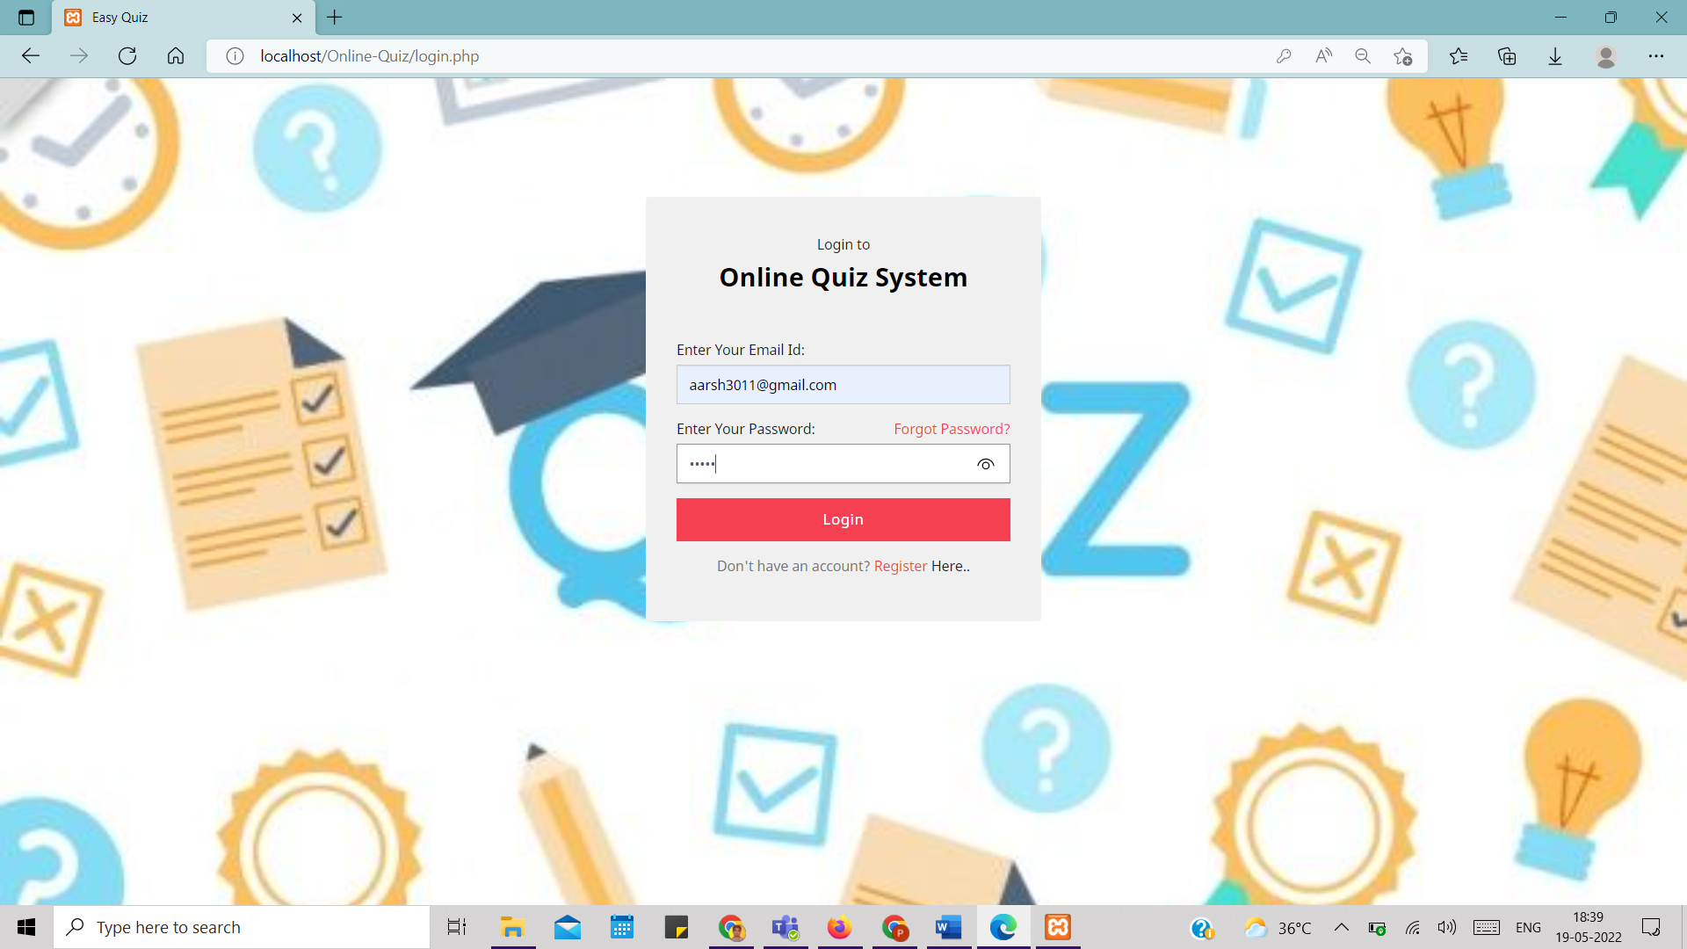

As the system checks and the information is true you are allowed to give the quiz or else if the information is wrong than it gives alert, so user can check his details and re enter the details and get login into the easy quiz

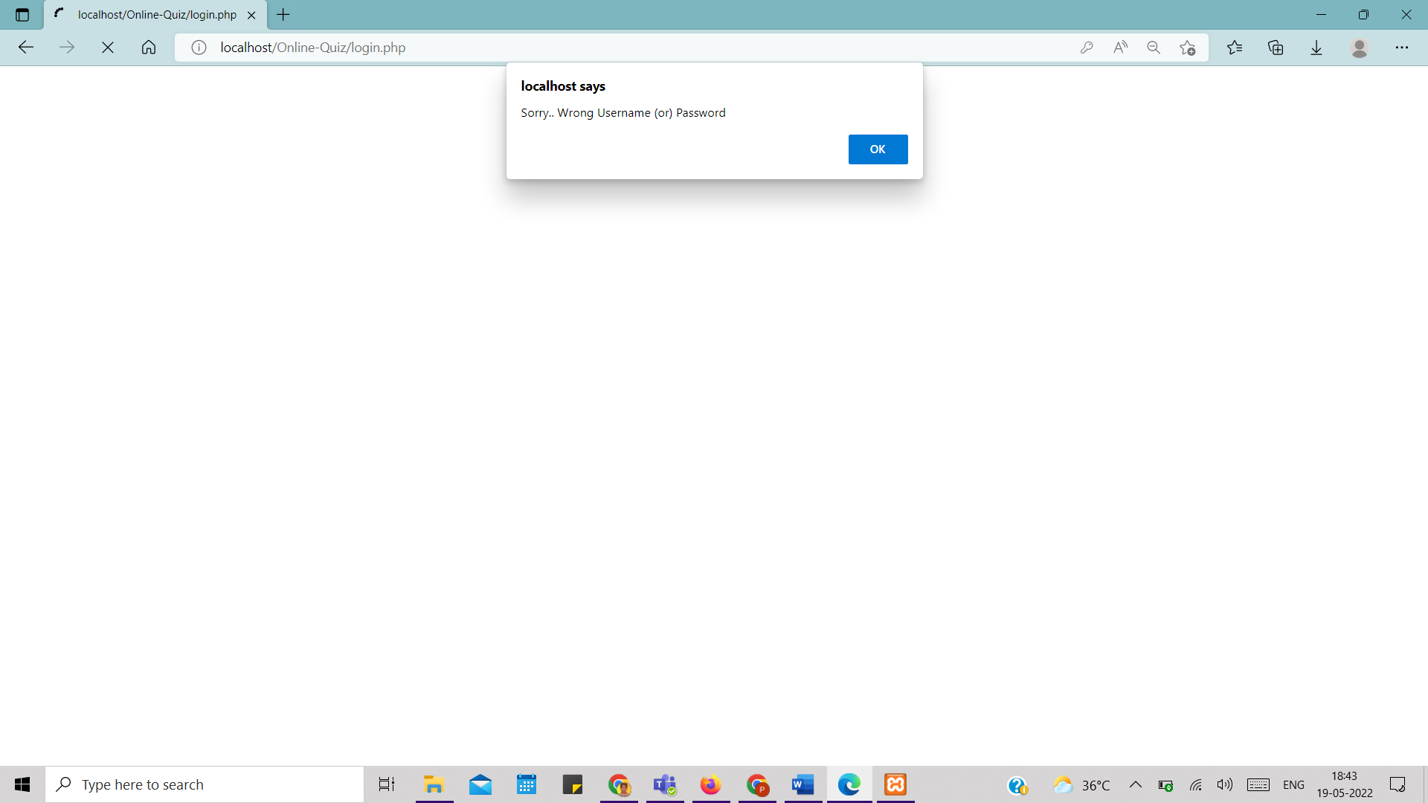

As you enter to the home page of these Easy Quiz user has option about which quiz to attend and the user can start or restart the quiz and acquire the knowledge of it

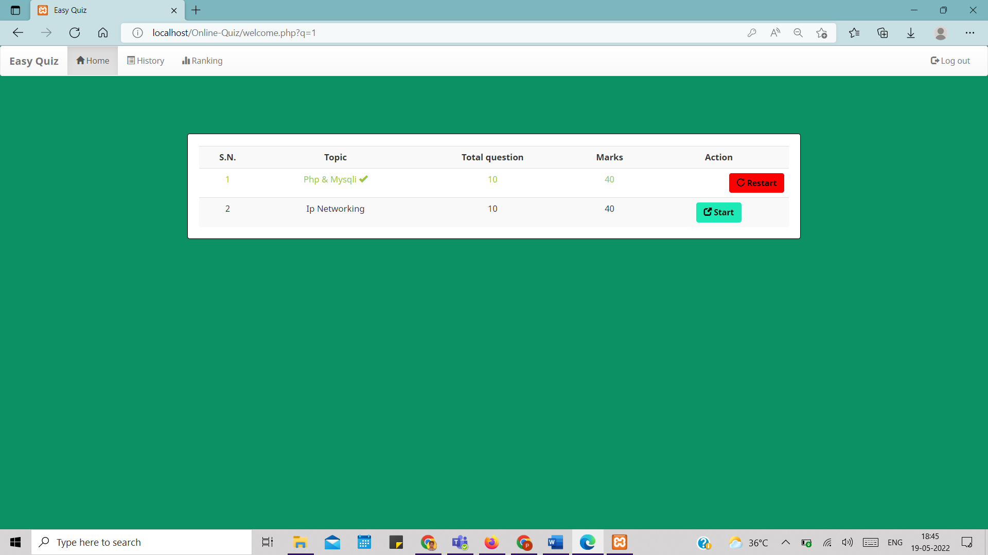

As the user start the question are display one by one and had to attend the quiz and as this question are being store in the database and they are retrieving from the database and display

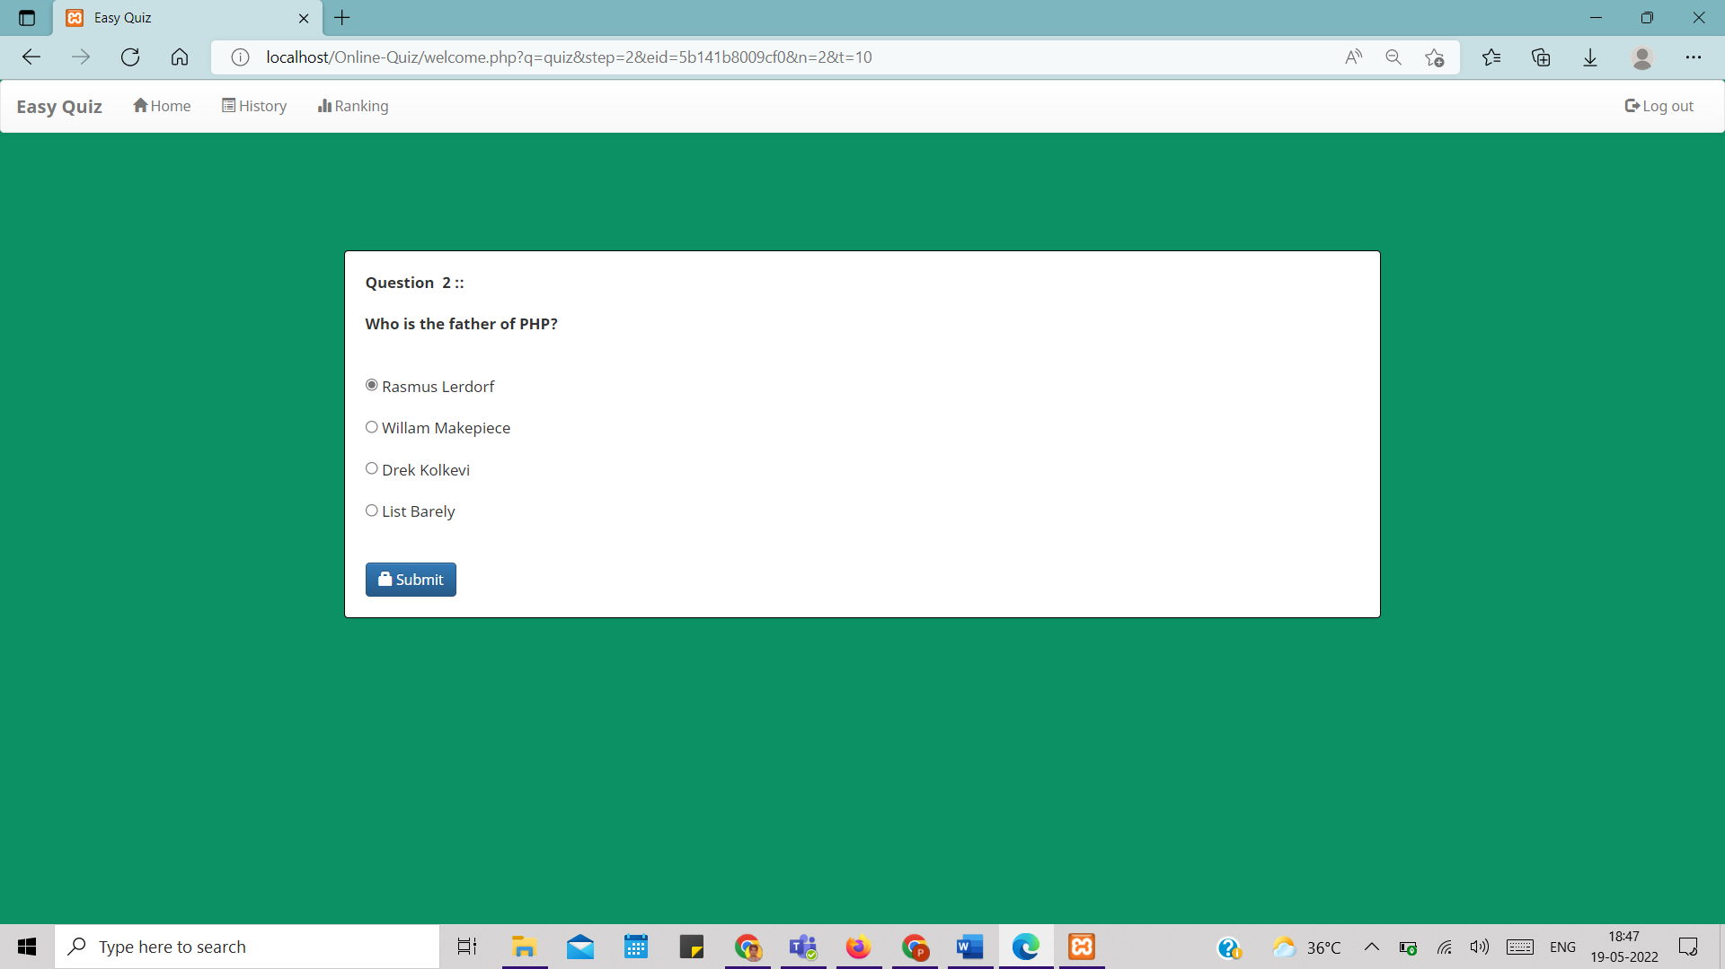

So, after attending the all question the result would be display as if the correct answer is there user will get +4 marks if the answer attend is wrong then user get -1 marks

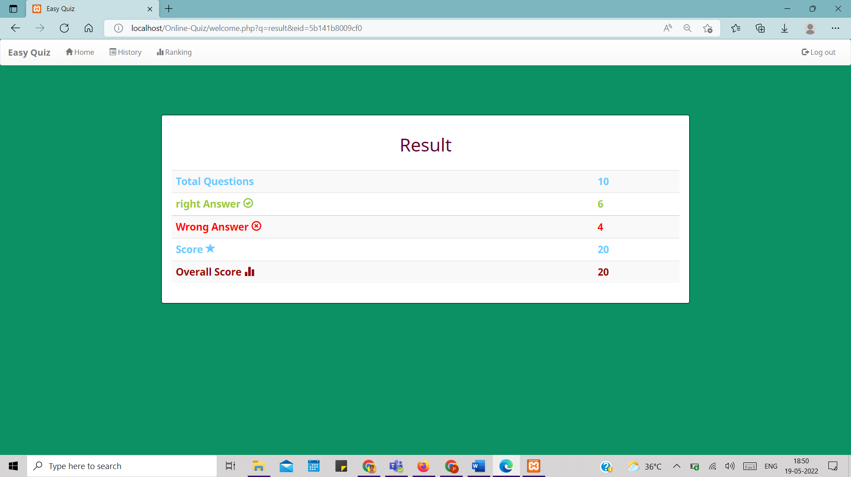

And One Thing it shows that is Ranking Tab, as the various user has attended the quiz so it shows ranking of marks of all the user

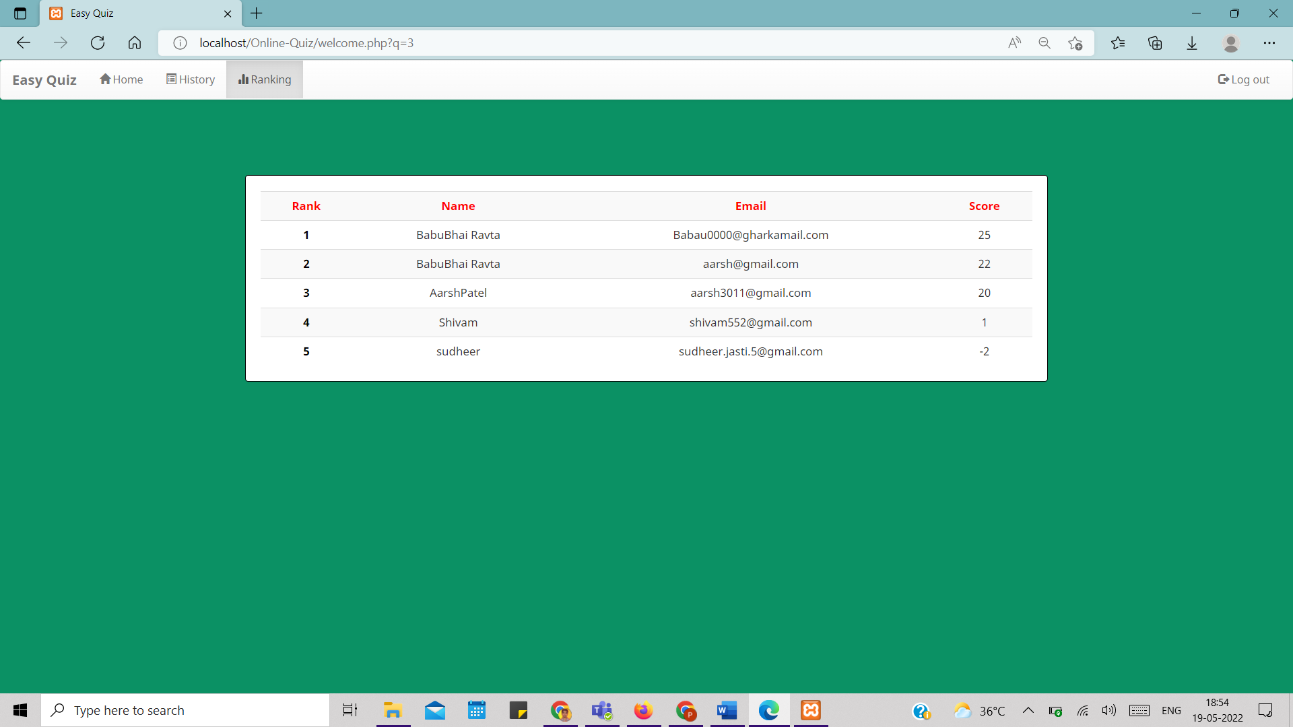

If there is multiple quiz then user can look in History tab and get the idea about how many quizzes user has attended it and score also

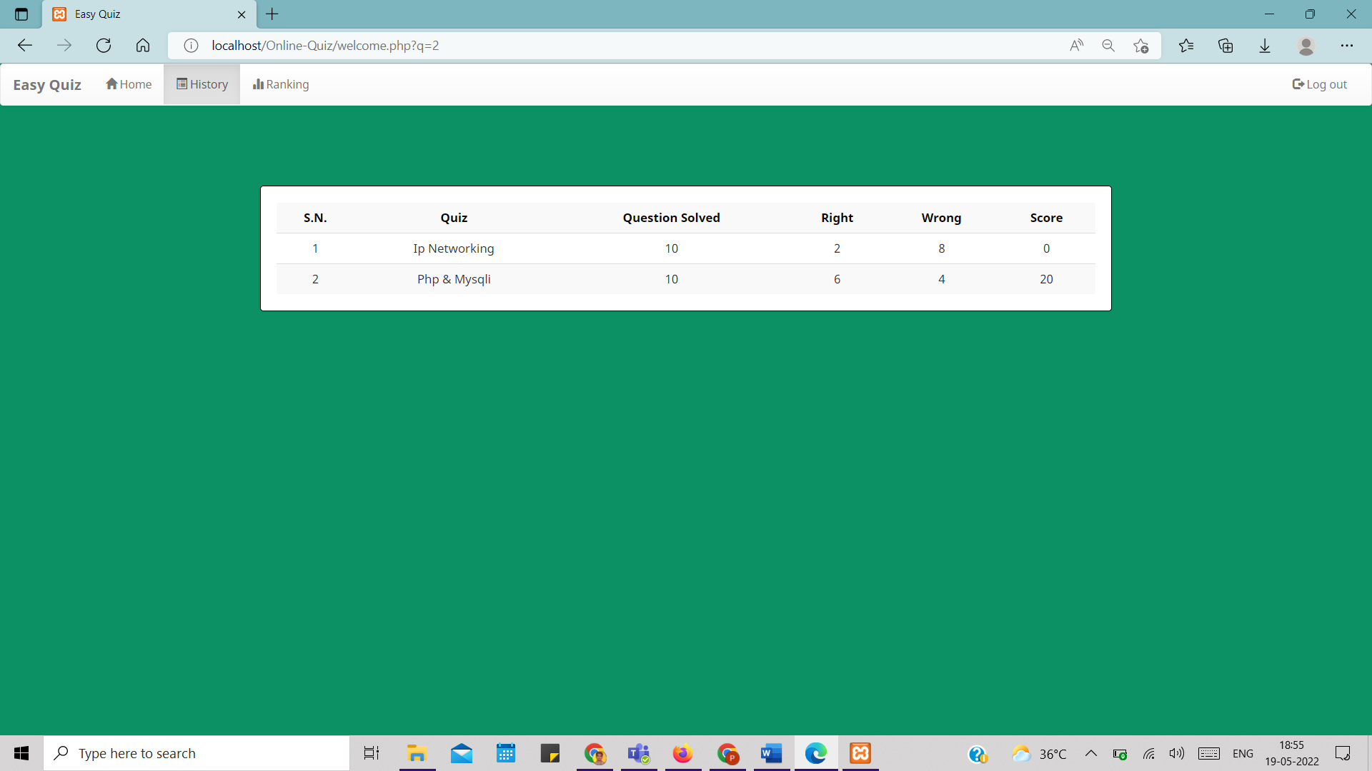

And Clicking on Logout user will get out of the quiz page and return back to login page

Here in the database all the user data are being store

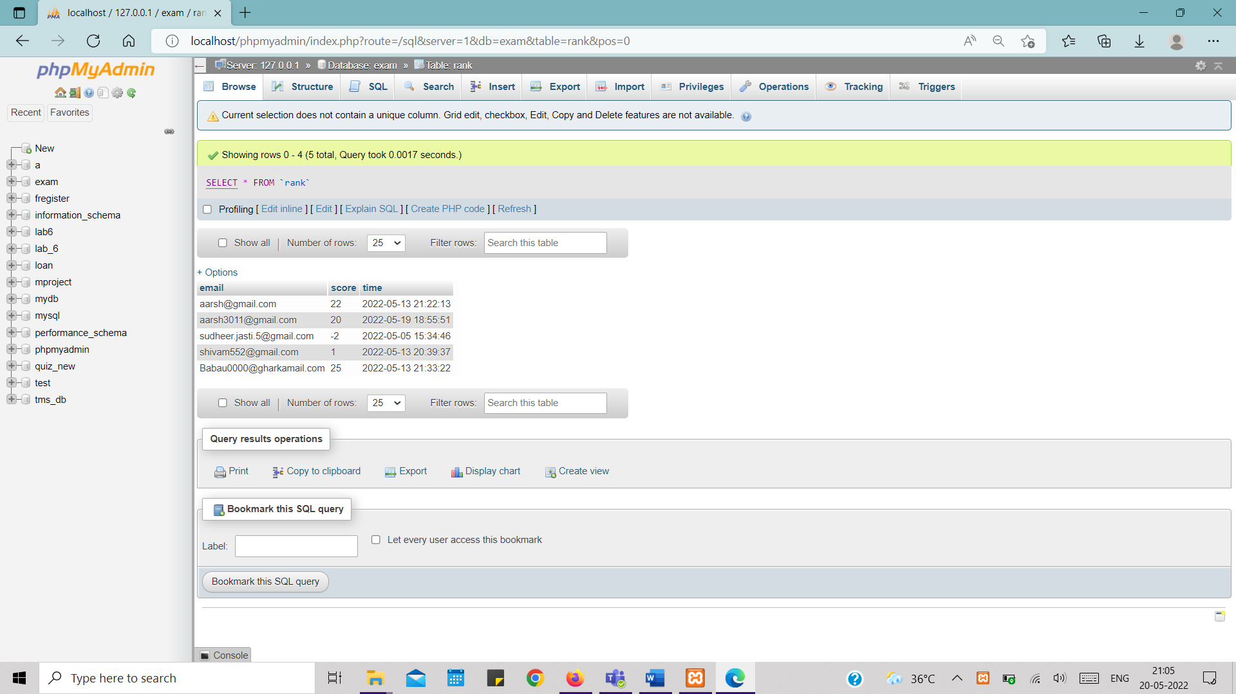

Here is the database of the register user all that data user have enter is being store in these database and can be use on later

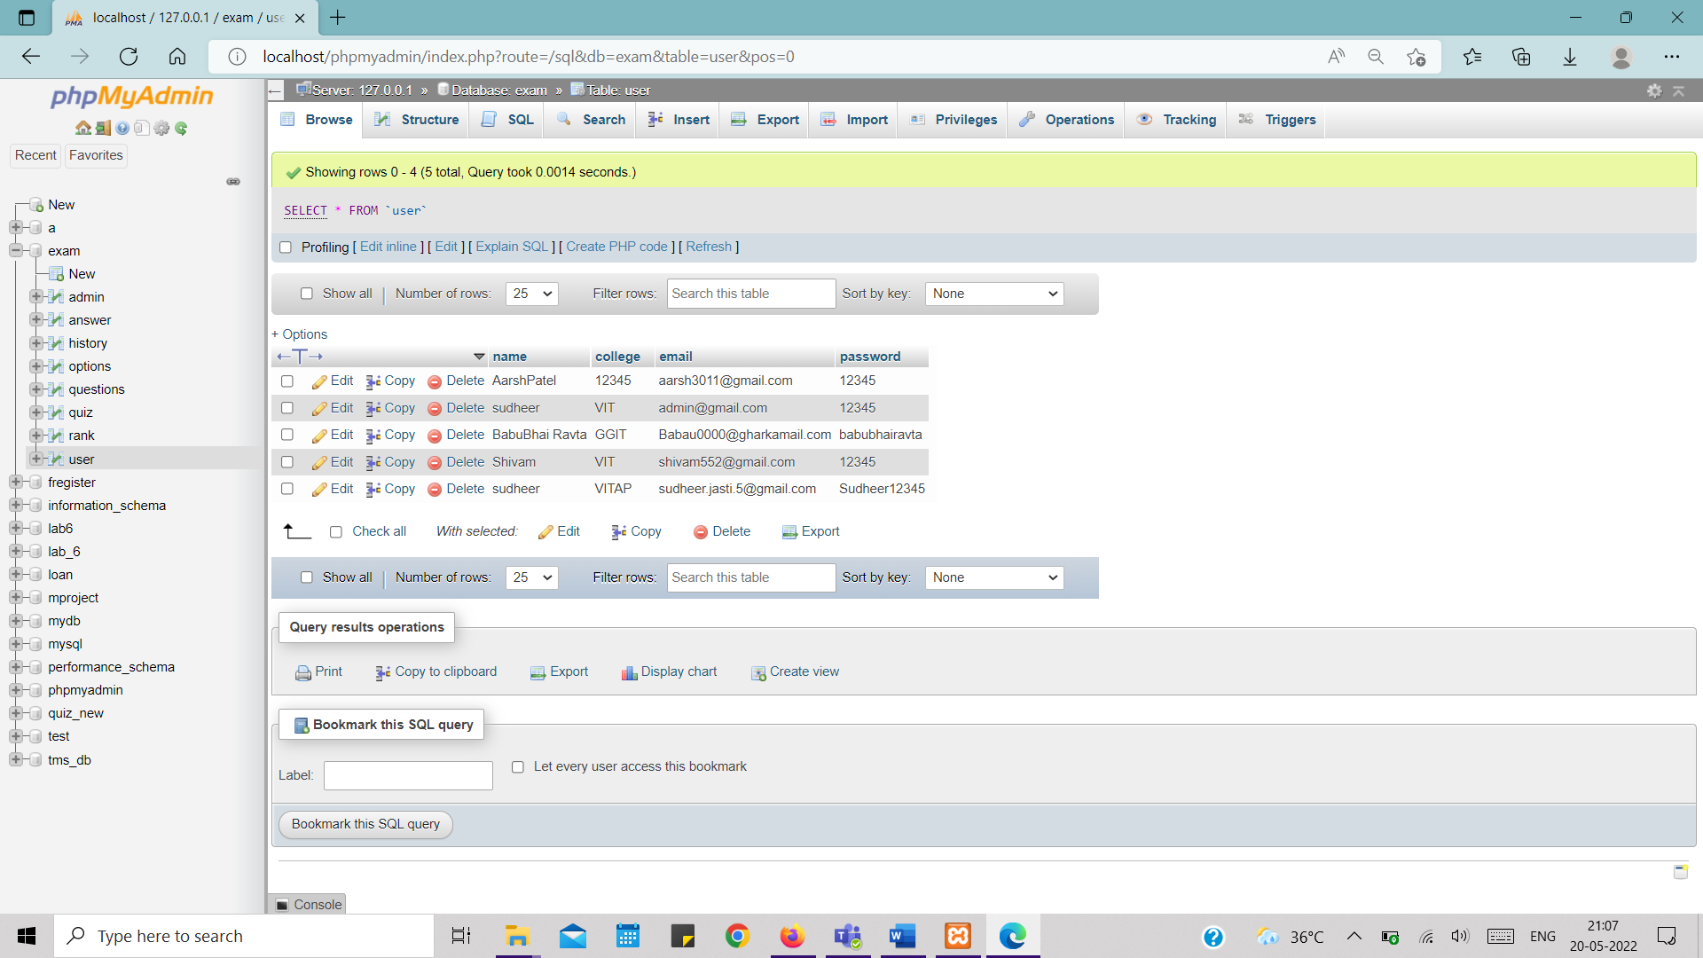

Future Works:

In Login I need to create a forget and change password function and it show change the password of the user if the user forgets his password by taking his email and checking and updating in the database of the user passwords

During Quiz there should be Finish button and Skip Button so User can go to next question or end the question so that I need to work on it

And Also Need to Make and option for those who are assigning the question to user so they can add /delete/update the question and options

Thank you;